ERD – Exercise Set 1 Solutions

4.

a.
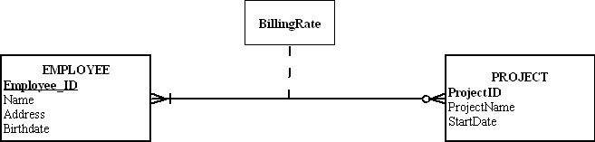

Yes, the attribute names do generally follow the guidelines for naming attributes.

b.

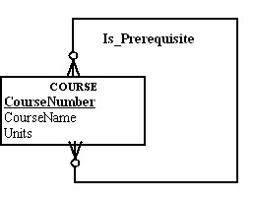

Course: A subject that is offered by a school. Course has a name and number as well as number of credits or units. A course also can have none, one, or more prerequisites. Course also can be a prerequisite for none, one, or many courses. A course may also be broken down into sections.
This definition is good since it describes the entity, several attributes as well as possible additional modeling that may be done (such as section)

c.

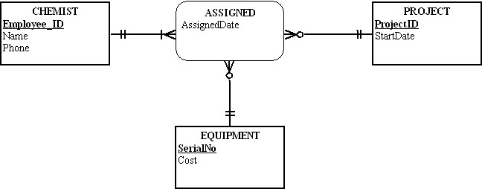

Assigned: All three entities participate in an assignment. However, EQUIPMENT and PROJECT do not need to participate in any assignments. All entities can have multiple assignments.
Works_on: This relationship was created to show what projects a chemist works on. In the case where no equipment is used for a project, there would be no way of showing an assignment using the Assigned relationship.

